- Challenge Name and Category: SUDO MAKE ME A SANDWICH (General Skills)
- Difficulty/Points: Easy
- Description: Can you read the flag? I think you can! ssh -p 58406 ctf-player@green-hill.picoctf.net using password 61ecc684
- Flag: picoCTF{ju57_5ud0_17_4c6f730f}
- Solution/Walkthrough: The first step is to ssh using the credentials provided by pico. When prompted to continue connect we will type “yes”. This will then connect us to ctf-player@green-hill’s host. From here we will command ls to list the files in the directory. This reveals a file named flag.txt. Now we will check the file permissions using the command ls -lh. ls lists the files but combining it with -lh will open it in long list format which shows us file permissions, ownership, size, and timestamps. The h portion of the command formats the long list in a human readable size. This shows us that the only one with the ability to read the file is root. We can potentially override this by checking the sudo permissions using sudo -l. User ctf-player may run the following commands on challenge: (ALL) NOPASSWD: /bin/emacs. We can run Emacs, a powerful extensible text editor that runs in the terminal. Emacs lets you open and edit files, navigate text efficiently, and run commands using keyboard shortcuts. In this instance we can use the command sudo emacs flag.txt which opens a new window containing the flag.

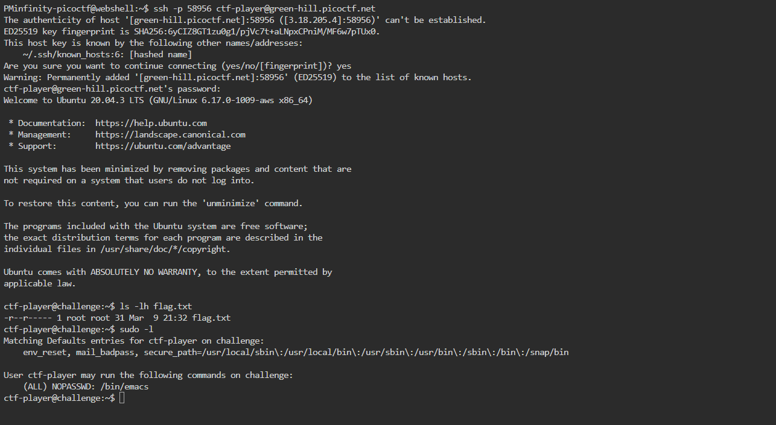
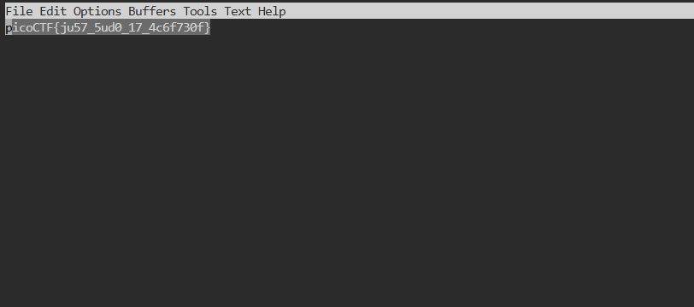
- Tools Used: Web Shell
- Hypothesis Formulation: I understood I needed to login using the ssh provided and issue a sudo command to retrieve the flag.
- What Worked vs. What Didn't: This challenge was working out fine until I got to Emacs. I didn’t understand it when it came up so I needed to research it to use it correctly.

